SIMATS ENGINEERING
ASSESSMENT TOOL 1: Case Study

COURSE NAME: | Query Processing for Data Science | COURSE CODE: | DSA0503

COURSE OUTCOME COVERED
CO4: Explore datasets using analytical techniques such as grouping, correlation detection, joining datasets, and extracting meaningful insights.

Assessment Tool Weightage: 35%
Total Marks: 20

Code of Conduct
I ___A.Pavithra(192424347)____ (Name / Reg No) certify that this submission is my original work and that I have adhered to the guidelines specified for this assessment.
I understand that any violation of academic integrity rules will result in disciplinary action.
Signature of the student: _A.Pavithra_______

Case Study Rubric
Criteria | Weightage | Level 4 – Exemplary | Level 3 – Proficient | Level 2 – Developing | Level 1 – Beginning
Understanding of Case | 25 | Thorough understanding; clearly identifies all key issues | Good understanding with most issues identified | Basic understanding; some issues missed | Poor understanding; problem not identified correctly
Application of Concepts | 25 | Effectively applies relevant concepts to analyze the case deeply | Applies appropriate concepts with minor gaps | Limited application of concepts | Fails to apply relevant concepts
Analysis | 20 | In-depth analysis with strong reasoning and insights | Good analysis with logical reasoning | Basic analysis with limited depth | Weak or no analysis; lacks reasoning
Solution Design | 20 | Innovative, feasible solutions with strong justification | Logical solutions with adequate justification | Basic solutions with weak justification | Incorrect or no solution provided
Clarity | 10 | Clear, well-structured, and easy to understand | Organized and understandable presentation | Limited clarity and structure | Poor clarity; difficult to understand

Total Marks Awarded:

Course Faculty signature of student

Questions:

1. Retail Sales Data Analysis
A retail company has collected sales data containing customer details, product categories, quantities, prices, purchase dates, and cities from different branches. Using Python and Pandas, import the dataset, explore its structure and table functions, identify missing or unusual values, create suitable groupings based on product category and city, and analyze total sales and quantity sold. Present the important findings using appropriate charts and provide a brief interpretation of the results.
Code:
import pandas as pd
import matplotlib.pyplot as plt
df = pd.read_csv("retail_sales.csv")
print(df.head())
print(df.info())
print(df.describe())
print(df.isnull().sum())
df["Sales"] = df["Quantity"] * df["Price"]
print(df.groupby("Product_Category")["Sales"].sum())
print(df.groupby("City")["Sales"].sum())
print("Total Sales:", df["Sales"].sum())
print("Total Quantity:", df["Quantity"].sum())
df.groupby("Product_Category")["Sales"].sum().plot(kind="bar")
plt.title("Category-wise Sales")
plt.show()
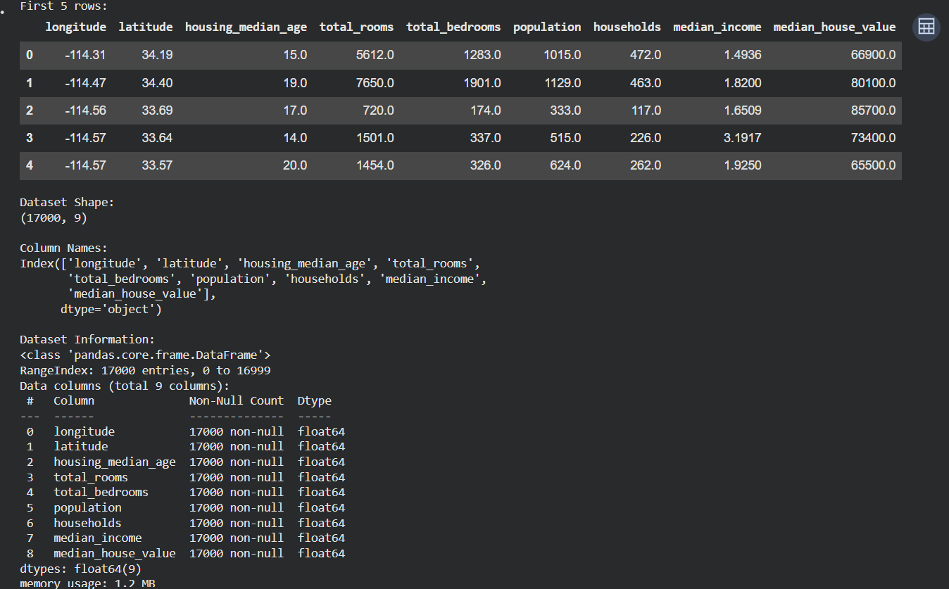

2. Customer Behavior Analysis
An online shopping company wants to understand customer purchasing behavior using a dataset containing customer ID, age, gender, location, product category, order value, and purchase date. Import and explore the data, separate relevant customer groups, analyze purchasing patterns, identify relationships between customer characteristics and order value, and identify any significant outliers. Present the findings using suitable visualizations and explain how the analysis can help the company improve its marketing strategy.
Code:
import pandas as pd
import matplotlib.pyplot as plt
df = pd.read_csv("customer_behavior.csv")
print(df.head())
print(df.info())
print(df.describe())
print(df.isnull().sum())

print(df.groupby("Gender")["Order_Value"].mean())
print(df.groupby("Product_Category")["Order_Value"].sum())
print("Average Order Value:", df["Order_Value"].mean())
print("Correlation:", df["Age"].corr(df["Order_Value"]))
df["Order_Value"].plot(kind="box")
plt.title("Order Value Outliers")
plt.show()
df.groupby("Gender")["Order_Value"].mean().plot(kind="bar")
plt.title("Order Value by Gender")
plt.show()
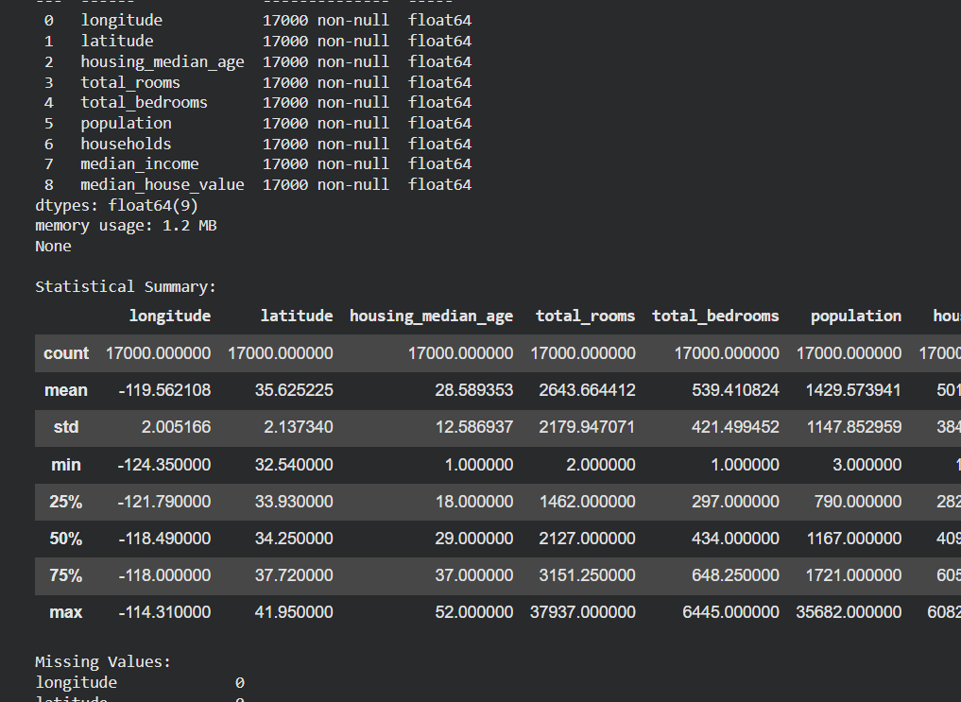

3. Student Academic Performance
A college has collected student information including student ID, department, attendance percentage, assignment marks, internal marks, examination marks, and semester results. Explore the dataset using Pandas, create groups based on departments, identify correlations between attendance and academic performance, detect unusual performance values, and analyze the factors associated with higher marks. Present the results using charts and provide suitable recommendations to improve student performance.
Code:
import pandas as pd
import matplotlib.pyplot as plt
df = pd.read_csv("student_performance.csv")
print(df.head())
print(df.info())
print(df.describe())
print(df.isnull().sum())
df["Total_Marks"] = (
df["Assignment_Marks"] +
df["Internal_Marks"] +
df["Examination_Marks"]
)
print(df.groupby("Department")["Total_Marks"].mean())
print("Correlation:")
print(df["Attendance_Percentage"].corr(df["Total_Marks"]))
df["Total_Marks"].plot(kind="box")
plt.title("Marks Outliers")
plt.show()
df.groupby("Department")["Total_Marks"].mean().plot(kind="bar")
plt.title("Department-wise Marks")
plt.show()
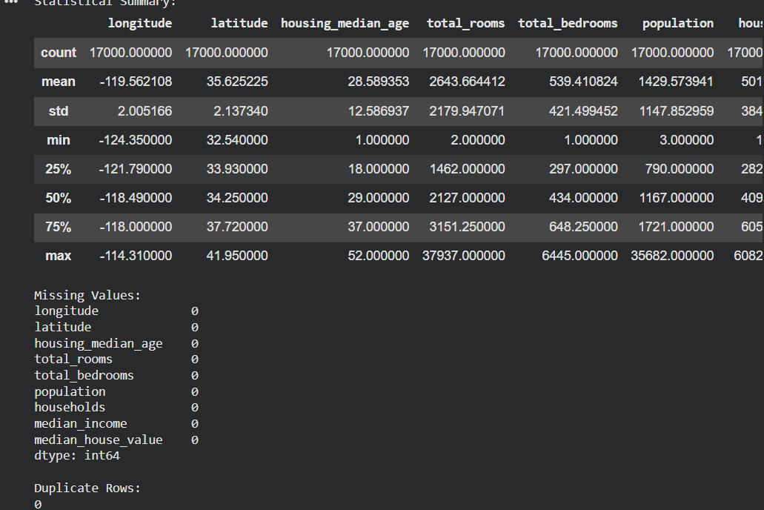
4. Healthcare Patient Analysis
A hospital maintains patient records containing age, gender, diagnosis, treatment type, admission date, length of stay, and medical expenses. Import and explore the dataset, identify outliers in patient age and treatment expenses, group patients according to diagnosis and treatment type, and analyze relationships between length of stay and medical expenses. Create appropriate visualizations, including time-related charts where applicable, and prepare a concise presentation of the major findings.
Code:
import pandas as pd
import matplotlib.pyplot as plt
df = pd.read_csv("healthcare_patients.csv")
print(df.head())
print(df.info())
print(df.describe())
print(df.isnull().sum())
print(df.groupby("Diagnosis")["Medical_Expenses"].mean())
print(df.groupby("Treatment_Type")["Medical_Expenses"].mean())

print("Total Expenses:", df["Medical_Expenses"].sum())
print("Correlation:",
df["Length_of_Stay"].corr(df["Medical_Expenses"]))
df["Medical_Expenses"].plot(kind="box")
plt.title("Medical Expense Outliers")
plt.show()
df.plot(
x="Length_of_Stay",
y="Medical_Expenses",
kind="scatter"
)
plt.title("Stay vs Medical Expenses")
plt.show()
